# Image credits Mushroom ID Map



<https://iconarchive.com/show/arcade-saturdays-icons-by-mad-science/Mushroom-Bonus-icon.html>



Created in Photopea editor



Created in Photopea editor

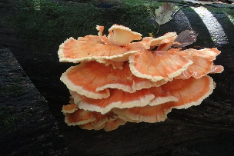

<https://commons.wikimedia.org/wiki/File:Chicken_of_the_Woods_Laetiporus_sulphureus.jpg>

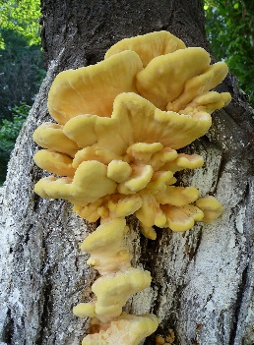

<https://commons.wikimedia.org/wiki/File:Laetiporus_sulphureus_2010_G1.jpg>

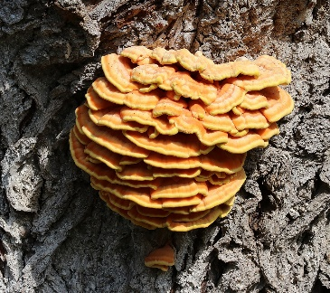

<https://commons.wikimedia.org/wiki/File:Laetiporus_sulphureus_2019_G1.jpg>

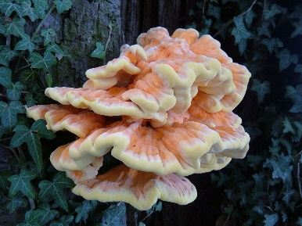

<https://commons.wikimedia.org/wiki/File:Laetiporus_sulphureus_1.JPG>

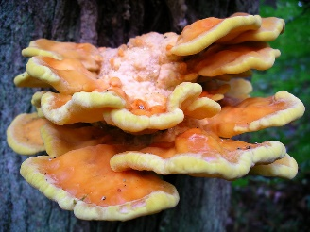

[**https://commons.wikimedia.org/wiki/File:Laetiporus_sulphureus.jpg**](https://commons.wikimedia.org/wiki/File:Laetiporus_sulphureus.jpg)

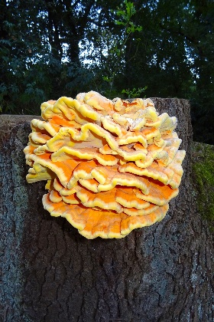

<https://commons.wikimedia.org/wiki/File:20160926_Elfenbankje_Hoenderloo.jpg>

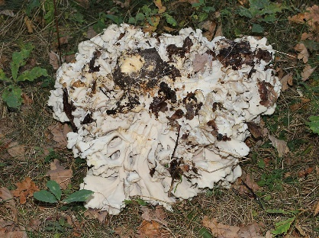

<https://commons.wikimedia.org/wiki/File:Grifola_frondosa_2014_G2.jpg>

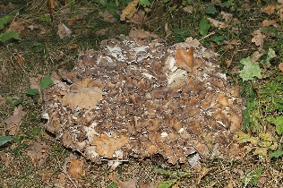

<https://commons.wikimedia.org/wiki/File:Grifola_frondosa_2014_G1.jpg>

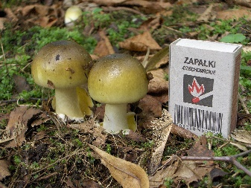

[https://en.wikipedia.org/wiki/Amanita_phalloides#/media/File:Amanita_phalloides_young.jpg](https://en.wikipedia.org/wiki/Amanita_phalloides%23/media/File:Amanita_phalloides_young.jpg)

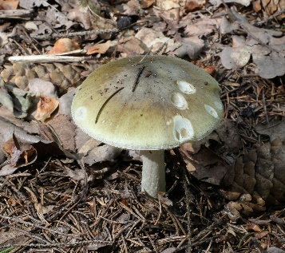

<https://commons.wikimedia.org/wiki/File:Amanita_phalloides_2011_G3.jpg>

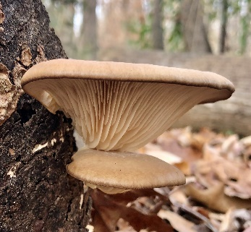

<https://commons.wikimedia.org/wiki/File:Pleurotus_ostreatus_109117645.jpg>

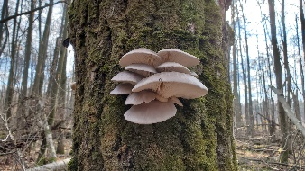

<https://commons.wikimedia.org/wiki/File:Pleurotus_ostreatus_103128460.jpg>

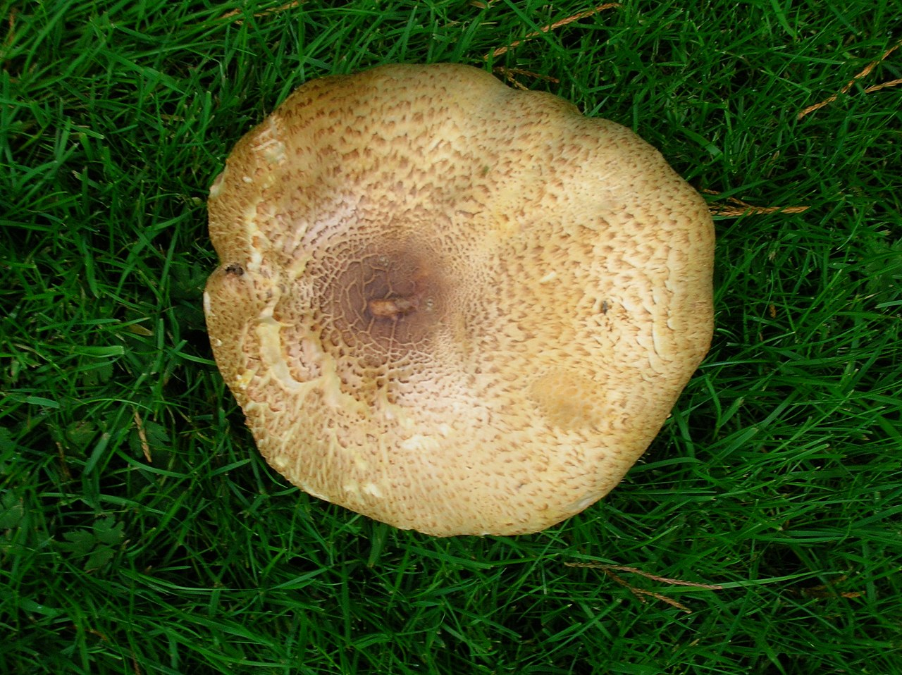

[https://en.wikipedia.org/wiki/Agaricus_augustus#/media/File:Agaricus_augustus_The_Prince.JPG](https://en.wikipedia.org/wiki/Agaricus_augustus%23/media/File:Agaricus_augustus_The_Prince.JPG)

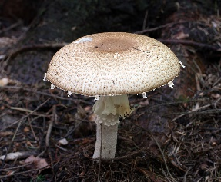

[https://en.wikipedia.org/wiki/Agaricus_augustus#/media/File:Agaricus_augustus_2011_G1.jpg](https://en.wikipedia.org/wiki/Agaricus_augustus%23/media/File:Agaricus_augustus_2011_G1.jpg)

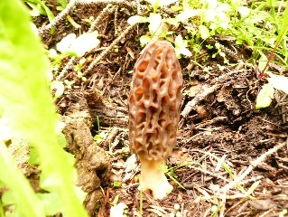

<https://commons.wikimedia.org/wiki/File:Morel_mushroom_growing_in_a_forest.jpg>

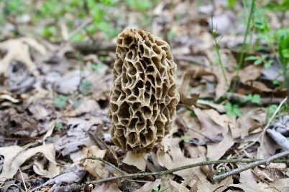

<https://commons.wikimedia.org/wiki/File:Morchella_americana_66730870.jpg>

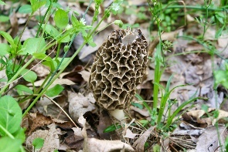

<https://commons.wikimedia.org/wiki/File:Morchella_americana_66730853.jpg>

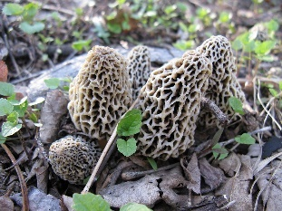

<https://commons.wikimedia.org/wiki/File:White_Morel_IMG_0399.JPG>

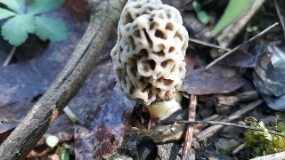

<https://commons.wikimedia.org/wiki/File:Morchella_americana_67632986.jpg>

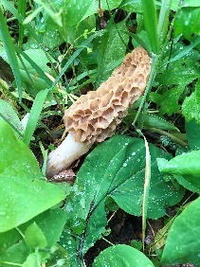

<https://commons.wikimedia.org/wiki/File:Morchella_americana_69515767.jpg>

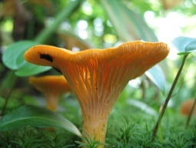

<https://commons.wikimedia.org/wiki/File:Chanterelle.jpg>

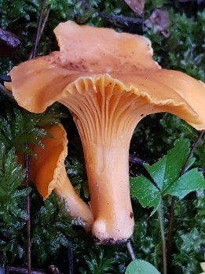

<https://commons.wikimedia.org/wiki/File:Cantharellus_cibarius_55979173.jpg>

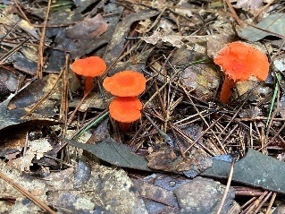

<https://commons.wikimedia.org/wiki/File:Cantharellus_cinnabarinus_97341526.jpg>

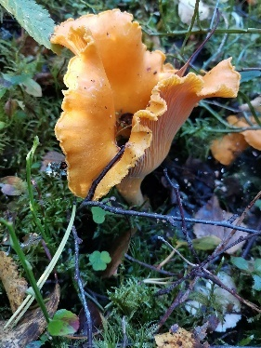

<https://commons.wikimedia.org/wiki/File:Cantharellus_cibarius_95990053.jpg>

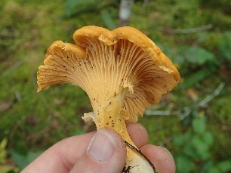

<https://commons.wikimedia.org/wiki/File:Cantharellus_cibarius_102451892.jpg>

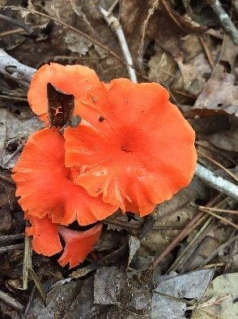

<https://commons.wikimedia.org/wiki/File:Red_Chanterelle_Durham_NC.jpg>

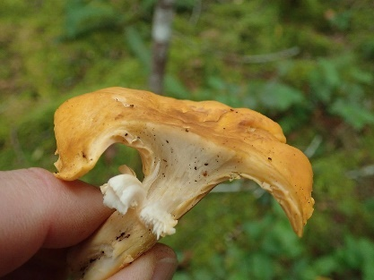

<https://commons.wikimedia.org/wiki/File:Cantharellus_cibarius_102451882.jpg>

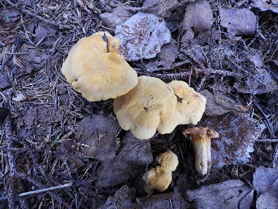

<https://commons.wikimedia.org/wiki/File:Cantharellus_cibarius_85451485.jpg>

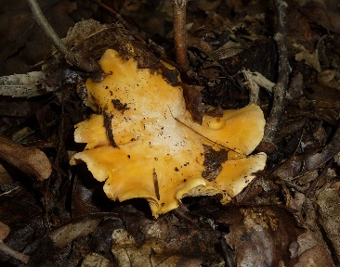

<https://commons.wikimedia.org/wiki/File:Cantharellus_cibarius_2009_G4.jpg>

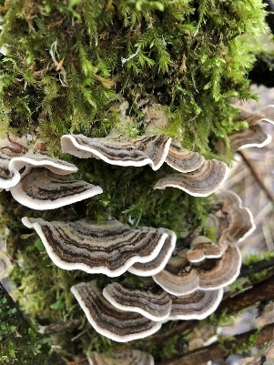

<https://commons.wikimedia.org/wiki/File:Trametes_versicolor_111395300.jpg>

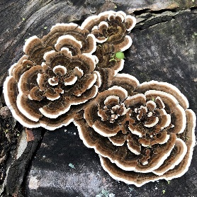

<https://commons.wikimedia.org/wiki/File:Trametes_versicolor_93075730.jpg>

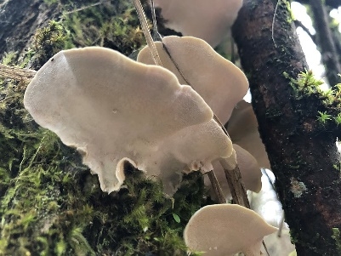

<https://commons.wikimedia.org/wiki/File:Trametes_versicolor_111395316.jpg>

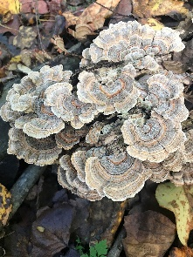

<https://commons.wikimedia.org/wiki/File:Trametes_versicolor_100281756.jpg>

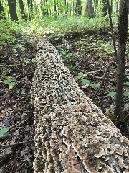

<https://commons.wikimedia.org/wiki/File:Trametes_versicolor_95688328.jpg>

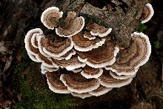

<https://commons.wikimedia.org/wiki/File:Turkey_tail_Fungus._(41856600312).jpg>

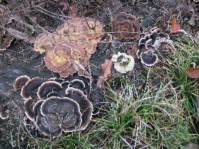

<https://commons.wikimedia.org/wiki/File:20121112Trametes1.jpg>

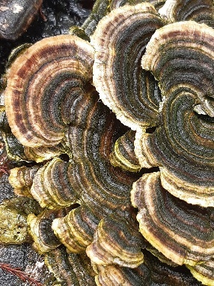

<https://commons.wikimedia.org/wiki/File:Trametes_versicolor_105537199.jpg>

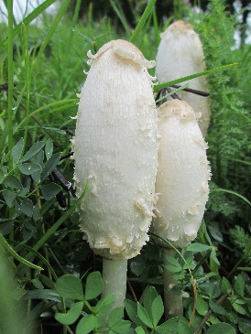

<https://commons.wikimedia.org/wiki/File:20191010Coprinus_comatus1.jpg>

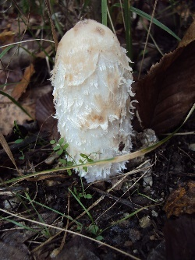

<https://commons.wikimedia.org/wiki/File:Coprinus_comatus_Podkomorsk%C3%A9_lesy.jpg>

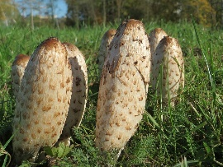

<https://commons.wikimedia.org/wiki/File:20171031Coprinus_comatus.jpg>

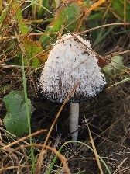

<https://commons.wikimedia.org/wiki/File:Coprinus_comatus_Kiev3.jpg>

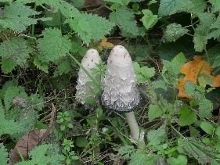

<https://commons.wikimedia.org/wiki/File:Coprinus_comatus_102781302.jpg>

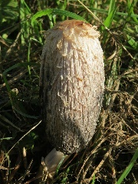

<https://commons.wikimedia.org/wiki/File:20171027Coprinus_comatus5.jpg>

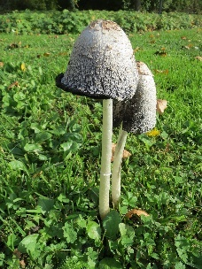

<https://commons.wikimedia.org/wiki/File:20131022Coprinus_comatus3.jpg>

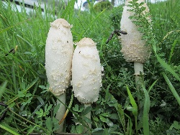

<https://commons.wikimedia.org/wiki/File:20191010Coprinus_comatus2.jpg>

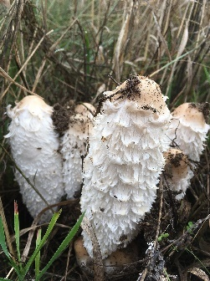

<https://commons.wikimedia.org/wiki/File:Coprinus_comatus_103573533.jpg>

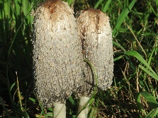

<https://commons.wikimedia.org/wiki/File:20171027Coprinus_comatus3.jpg>

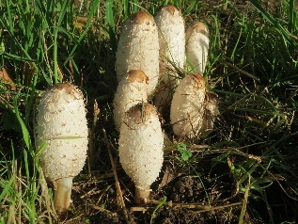

<https://commons.wikimedia.org/wiki/File:20171027Coprinus_comatus6.jpg>

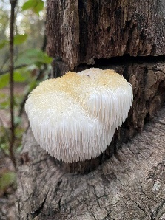

<https://commons.wikimedia.org/wiki/File:Lions_Mane_Mushroom_Durham_NC.jpg>

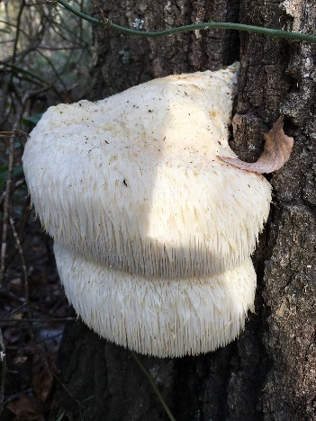

<https://commons.wikimedia.org/wiki/File:Hericium_erinaceus_104664221.jpg>

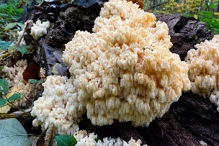

<https://commons.wikimedia.org/wiki/File:Hericium_coralloides_Avala.jpg>

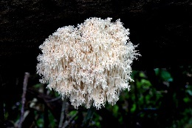

<https://commons.wikimedia.org/wiki/File:Hericium_coralloides._(38793106882).jpg>

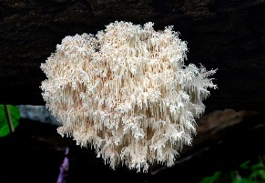

<https://commons.wikimedia.org/wiki/File:Hericium_coralloides._(13844408165).jpg>

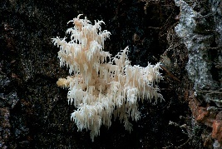

<https://commons.wikimedia.org/wiki/File:Hericium_coralloides._(12427390323).jpg>

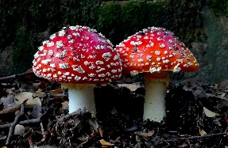

<https://commons.wikimedia.org/wiki/File:Amanita_muscaria,_Fly_agaric._(36155540884).jpg>

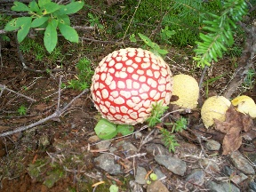

<https://commons.wikimedia.org/wiki/File:Amanita_muscaria_closeup.jpg>

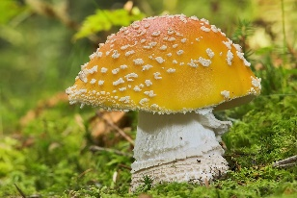

<https://commons.wikimedia.org/wiki/File:AD2009Sep20_Amanita_muscaria_02.jpg>

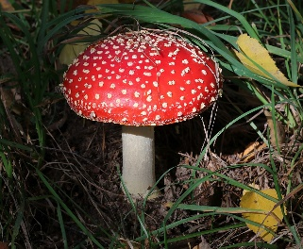

<https://commons.wikimedia.org/wiki/File:Amanita_muscaria_2018_G01.jpg>

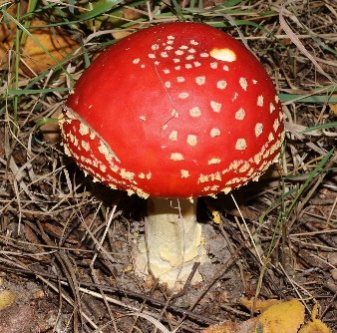

<https://commons.wikimedia.org/wiki/File:Amanita_muscaria_2018_G04.jpg>

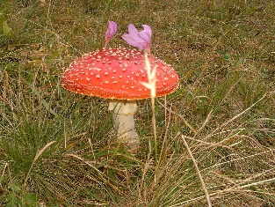

<https://commons.wikimedia.org/wiki/File:Amanita_muscaria23.JPG>

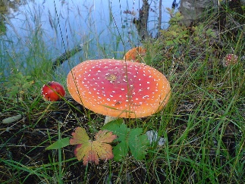

<https://commons.wikimedia.org/wiki/File:Amanita_muscaria_in_Sweden.jpg>

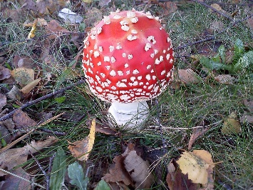

<https://commons.wikimedia.org/wiki/File:Amanita_Muscaria_003.jpg>

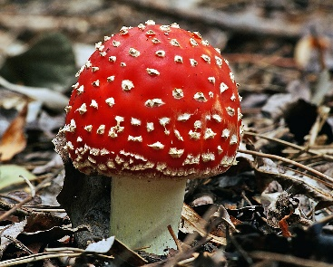

<https://commons.wikimedia.org/wiki/File:Amanita_muscaria_(2)_(8621141690).jpg>

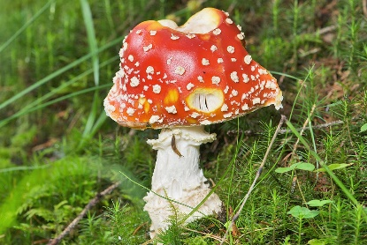

<https://commons.wikimedia.org/wiki/File:AD2009Sep15_Amanita_muscaria_var._muscaria_02.jpg>